# Lab title: Quantum Entanglement

Contact person:

Frank Setzpfandt  
phone: +49 (0) 3641 947569  
e-mail: [f.setzpfandt@uni-jena.de](mailto:f.setzpfandt@uni-jena.de)

Student name: Vishnuthirtha Sandur Huliraj

Name of teaching assistant: Saniya Shinde

Date of lab: 16/01/2025

Date of report submission: 23/01/2025

## Introduction

In this experiment on quantum entanglement, we aimed to explore the fundamental principles of quantum mechanics by generating and analysing entangled photon pairs. Using spontaneous parametric down-conversion (SPDC) and a carefully aligned setup involving crossed BBO crystals, we produced maximally entangled Bell states. The experiment involved verifying entanglement through the CHSH inequality, characterizing quantum states using state tomography, and analysing density matrices for both entangled and separable states. The results provided insights into quantum correlations and demonstrated the unique properties of entanglement compared to classical systems.

## Theoretical background

***The Spooky Action at a distance***

Before getting into EPR Paradox and Bell’s Inequality let us see what are basics behind these famous theories. Firstly, the general state of the physical system |𝜓⟩ is defined by a vector in Hilbert Space $H$. Consider a Single Qubit, let us say a photon, the corresponding photon’s polarization in this Hilbert Space is having dimension n=2 such that the state can be expressed in the superposition of two orthogonal basis vectors say |𝐻⟩ and |𝑉⟩. The superposition is expressed as follows,

[1]

$$\left|ψ\right\rangle = α\left|H\right\rangle + β\left|V\right\rangle$$

Any state that is present in 2D Hilbert Space can be visually represent in sphere called *Bloch Sphere.* In the Bloch Sphere, angle $θ$ shows the position of the vector along the equatorial plane and angle $ϕ$ represents the phase difference between two linearly polarised basis states.

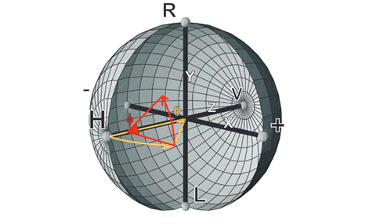

Figure 01: Bloch Sphere representing 2-dimensional Hilbert Space

Measurement of the state $\left|ψ\right\rangle$ is basically represented by Hermitian operators. One of the Hermitian Operators that does this job is the Projector Operator P. As an example, if I want to measure the $\left|ψ\right\rangle$ state along vertical polariser. I have to calculate the expectation value of $P_{v}$ meaning, The expectation value of 〈 $P_{v}$〉 gives the probability of measuring $\left|ψ\right\rangle$ along the |𝑉⟩.

When we consider a 2-Qubit System, which might be possibly “Entangled!?”. To describe these sorts of qubits the normal two-dimensional Hilbert space is not enough and we need higher dimension of Hilbert space for such conditions i.e., Four-Dimensional Hilbert Space. This is because by definition, the two-qubit case is obtained by taking the tensor product of the two single-qubit spaces.

[2]

$$H_{1,2}:H= H_{1}⨂H_{2}= |H_{1}H_{2}⟩$$

The major key points here are that, if two-qubit state can be directly written as tensor product of two single qubits and these are called as “Separable” or “product” states meaning no entanglement see the Eq[2]. If we cannot express them as Separable States then, we can say that the states are in Coherent Superposition meaning they are “Entangled” Eq[3].

$$\left|ψ\right\rangle =\frac{1}{\sqrt{2}}(|H_{1}H_{2}⟩+|V_{1}V_{2}⟩)$$

The State being in entanglement plays a crucial role when we perform measurement. In the case of Entanglement when we perform measurement, it is clear that the probability of measuring either |𝐻⟩ or |𝑉⟩ is 50%. So, If I found the polarization basis state of 1-qubit, then by the principle of quantum mechanics depending on the which bell state we are considering here, the state of the second qubit becomes obvious. This is true even when two photons are separated by a very large distance. Albert Einstein phrased this as the “Spooky Action at a distance” implying that quantum mechanics doesn’t follow “Local Realism”.

[3]

***EPR-Paradox, Bell test and CHSH-Inequality***

This concept of "non-locality" is what challenged Einstein. Together with his colleagues Boris Podolsky and Nathan Rosen (EPR), he proposed a theory that essentially suggested quantum mechanics is incomplete. They hypothesized the existence of "Hidden Variables," which, if considered, could bring quantum mechanics back to a "Local Model," eliminating the need for non-locality. To test this idea, John Bell proposed a solution by deriving an inequality. This inequality demonstrated that if it was upheld, the model would be local; if violated, the model would not adhere to locality. When tested against the EPR paper's assumptions, Bell's Inequality was violated, proving that the "non-local" description of quantum mechanics is correct.

[4]

After Bell’s Test, John Clauser, Michael Horne, Abner Shimony and Richard Holt (CHSH) came up with CHSH test which also resulted in favouring the “non-local” description of quantum mechanics. The result of the CHSH test is as follows,

$$S(α,α',β,β') = |E(α,β) +E(α',β) -E(α,β')+E(α',β')| ≤ 2.$$

In the CHSH-inequality test, the parameter S(𝛼, 𝛼′, 𝛽, 𝛽′) helps determine whether the behaviour of the photons being measured follows classical local realism theory or quantum non-local theory. If the S-parameter is less than or equal to 2, the photons follow local realism theory. If it exceeds 2, it indicates quantum mechanical non-local behaviour. The S-parameter is calculated by summing the correlation measurements of the polarization angles of the photons. Specifically, E(𝛼, 𝛽) represents the correlation measurement between the photons at angles 𝛼 and 𝛽, showing how the measurement at angle 𝛼 is related to the measurement at angle 𝛽. There are three other combinations of correlation measurements that contribute to the S-parameter.

So, when perform CHSH Inequality test for the Bell States we can clearly see the violation of the CHSH Test. The Maximum Value that S-parameter can take is $S= 2 \sqrt{2}≈2.82>2$. Therefore, it clearly violates the classical limit that was derived to test the validity of local hidden-variable theories.

***Density Matrices and Quantum State Tomography***

Quantum State Tomography is a technique used to determine the quantum state of given single or multiple qubits. A tomographic measurement is carried out by performing measurements that attempt to reconstruct the properties of the state through projection measurements. This process is analogous to illuminating a 3D object with light from different angles and recording its 2D shadow on various planes. Using these recorded projections, the original 3D object can be reconstructed. Similarly, in quantum state tomography, by taking projections of the quantum state (the "state" here is analogous to the 3D object) onto different basis states (analogous to the 2D shadows on planes), the quantum state can be reconstructed using these projections.

For example, to determine the polarization of a photon, its state is projected onto different polarization bases. However, a single photon cannot be measured in multiple bases due to the quantum mechanical principle of measurement collapse, which destroys the original state after measurement. To address this, multiple identical copies of the photon state are prepared, allowing measurements in different bases. This is practically achieved using Spontaneous Parametric Down-Conversion (SPDC), a process that reliably generates identical photon pairs for such experiments.

For the measurement of the polarisation of the state of the photon for the classical case was devised by Stokes in 1852 it was called as “Stokes Parameters ($S_{i})$” where i = 0,1,2,3. For the Quantum Mechanics case Stokes parameters don’t work so we take a more compact form called as “Density Matix”. While knowing the Stokes parameters we can get the density matrix $\hat{ρ}$ as follows,

[5]

$$\hat{ρ}= \frac{1}{2}\sum_{i=0}^{3}{\frac{S_{i}}{S_{0}}}\hat{σ_{i}}$$

Here $\hat{σ_{i}}$ shows the Pauli Matrices.

If we know the state $\left|ψ\right\rangle$ then we can directly compute the density matrix just by taking the projection of the state on itself.

[6]

$$\hat{ρ}= \left|ψ\right\rangle ⟨ψ|$$

In real cases, we don’t see a single pure state qubit, but rather a mixture of several pure states $\left|ψ_{i}\right\rangle$ each occurring with a probability of $p_{i}$. The density matrix accounts this mixedness of the several pure states and by summing up the contribution of each pure state in this case density matrix can be obtained as,

[7]

$$\hat{ρ}= \sum_{i}{p_{i}}\left|ψ_{i}\right\rangle ⟨ψ_{i}|$$

In the context of Quantum State Tomography, when we perform measurements, it was found that for a single qubit system we just need 4 measurements to full characterise it. For two-qubit system, we need 16 measurements and so on. We can therefore say that for a system of n-qubits we need $4^{n}$ measurements to characterise it. Speaking about the density matrix, One-qubit system is basically described by 2x2 Matrix and a Two-qubit system is described by 4x4 Matrix.

The purity of state can be explained by density matrix $\hat{ρ}$ constructed from $\left|ψ\right\rangle$, if $\hat{ρ^{2}}= \hat{ρ}$ and their trace values are also equal to 1 then, we can say that $\hat{ρ}$ is a pure state and if $\hat{ρ}$ is a mixed state then $\hat{ρ^{2}}≠ \hat{ρ}$ and their trace values are also not equal to 1, meaning Tr($\hat{ρ^{2}}$) < 1.

Maximum Likelihood Estimation (MLE) is a numerical method used to ensure that density matrix that we obtain is “most-likely” physically possible. If the density matrix violates this it might be due to experimental uncertainties.

## Experimental realization

The process of spontaneous parametric down-conversion (SPDC) is central to generating entangled photon pairs for quantum experiments. In this setup, a β-Barium-Borate (BBO) crystal is used as the nonlinear medium. When a high-energy "pump" photon from a UV laser diode (wavelength 405 nm) passes through the crystal, it occasionally decays into two lower-energy photons—termed the signal and idler photons—with identical wavelengths of 810 nm. This decay ensures the conservation of energy and momentum, fundamental to the process. The emitted photons follow specific trajectories along cones concentric to the pump beam's axis, dictated by phase-matching conditions within the crystal. To achieve entanglement, a second BBO crystal, with its optical axis rotated by 90°, is aligned with the first. The interplay between these crystals enables the production of maximally entangled Bell states, such as |Φ⁺⟩. A half-wave plate (HWP) ensures diagonal polarization of the excitation photons, while birefringent Ytterbium Vanadate (YVO) crystals compensate for any temporal or dispersion-induced phase shifts. This careful design allows indistinguishable photon pair generation, forming the basis for subsequent measurements.

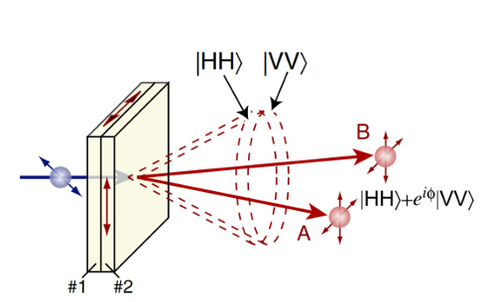

Figure 02: Principle of entangled state generation using two crossed BBO crystals and Type-I phase matching.

To fully characterize the quantum state of the entangled photon pair, quantum state tomography is performed. This requires measuring the two-photon system in a complete set of polarization bases, including horizontal (|H⟩), vertical (|V⟩), diagonal (|+⟩), and circular (|R⟩) polarizations. Linear polarizers, which were used earlier in the CHSH inequality measurements, allow the |H⟩, |V⟩, and |+⟩ basis states to be measured directly. However, to measure circular polarization, a quarter-wave plate (QWP) is introduced into the optical path before the linear polarizer. The QWP converts linearly polarized light into circularly polarized light, effectively acting as a "circular polarizer" when used in conjunction with the linear polarizer.

In the experimental setup, the photon pairs are sent through the tomography apparatus, where each combination of polarization basis is measured to reconstruct the density matrix of the quantum state. A schematic representation of this tomography process highlights the arrangement of the QWP and polarizer, demonstrating how each polarization basis is selected and measured.

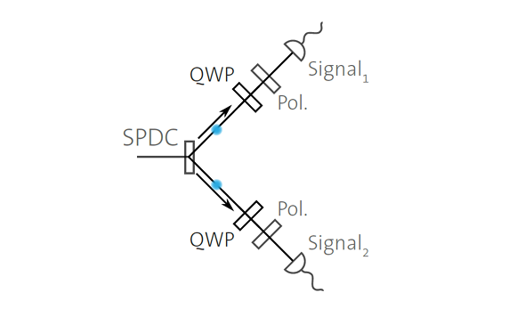

Figure 03: Optical Setup for Quantum Tomography experiment

## Measurement results and analysis

In the experiment, we began by generating entangled photon pairs through spontaneous parametric down-conversion (SPDC) using a setup with crossed BBO crystals. The polarization of the excitation photons was adjusted with a half-wave plate, and birefringent crystals were used to ensure coherence by compensating for any dispersion effects. To verify entanglement, we measured the CHSH inequality by adjusting the angles of the polarizers and recording the correlation curves using the quCNT application. The entangled and separable states were generated by placing and removing the half-wave plate, respectively, and the data for both states was analysed using the Qutools application to calculate the CHSH parameter and assess entanglement visibility. The following Correlation curves were obtained after performing this part of the experiment. The CHSH Markers show the values used to perform the CHSH test and calculate the S-Parameter.

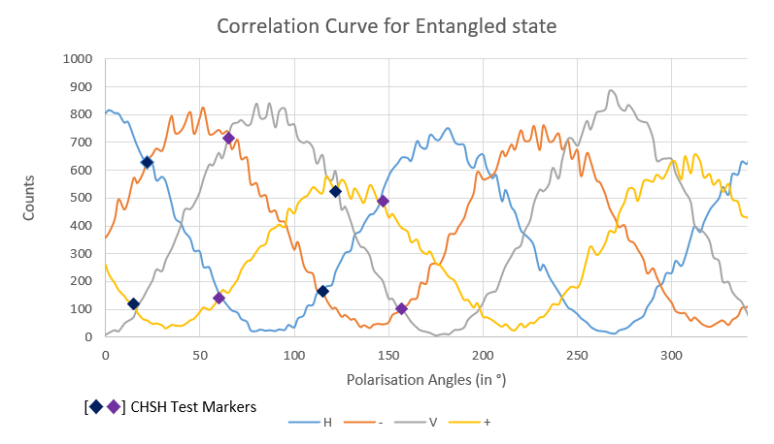

Figure 04: Correlation Curve for Entangled State.

Table 01

|  |  |  |
| --- | --- | --- |
| S-Parameter | CHSH Error | No. of Stdev |
| 2.591 | 0.062 | 9 |

The S-parameter must be S ≤ 2, but the S-parameter that we have obtained exceeds the limit of 2: S = 2.591 > 2. This shows a clear violation of the CHSH test. This is observed due to the entanglement of the state. The violation of the CHSH test shows that the quantum system needs to be treated as a 'non-local' entity and cannot follow classical theories.

The following plot was obtained for the Product state. The Following data was also obtained for the plot.

|  |  |  |
| --- | --- | --- |
| S-Parameter | CHSH Error | No. of Stdev |
| 1.536 | 0.079 | -5 |

Table 02

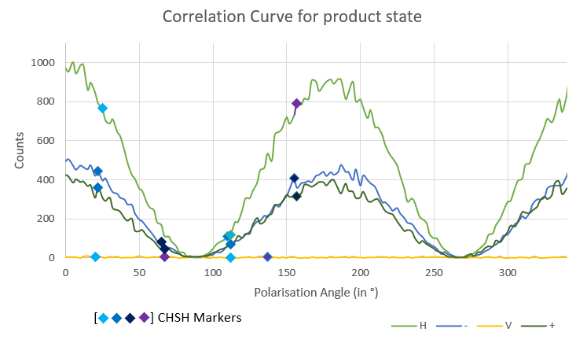From the obtained data, the S-parameter value, i.e., 1.536 < 2. This does not violate the CHSH inequality, indicating that the system adheres to the classical constraints of local realism. This result is due to the fact that the states are no longer entangled, meaning that quantum correlations are absent, and the system behaves as a classical, local system. The absence of entanglement reinforces that the observed phenomena can be fully described within the framework of classical physics, aligning with the principle of 'local realism,' which posits that physical properties are determined by local factors and that information cannot travel faster than the speed of light.

Figure 05: Correlation Curve for Product State.

The following data was obtained for Visibility of Entanglement.

|  |  |
| --- | --- |
| Raw Visibility for |HH⟩,|VV⟩ | 0.956303 |
| Corrected Visibility for |HH⟩,|VV⟩ | 0.969737 |
| Raw Visibility |PP⟩,|MM⟩ | 0.840678 |
| Corrected Visibility for |PP⟩,|MM⟩ | 0.852497 |

Table 03

The above data is for the Correlation Measurement for Entanglement State (Figure 04). From the data present in the Table 03, we can clearly that Both polarization pairs (HH, VV and PP, MM) show relatively high visibility after correction, suggesting strong quantum correlations. The corrected visible values are close to 1 indicating that the system is likely in a maximally entangled state. The variations in the visibility might be due to experimental imperfections which might be masking the entanglement. But the correction has allowed us to see that the corrected values are closer to 1. Hence, we can conclude that the State is Entangled.

The following data for the Product State was obtained to check the visibility of entanglement.

|  |  |
| --- | --- |
| Raw Visibility for |HH⟩,|VV⟩ | 0.985222 |
| Corrected Visibility for |HH⟩,|VV⟩ | 0.988359 |
| Raw Visibility |PP⟩,|MM⟩ | 0.032419 |
| Corrected Visibility for |PP⟩,|MM⟩ | 0.0327965 |

Table 04

From the data present in the above table 04. The lack of significant improvement in visibility in the PP, MM basis suggests that the product state is no longer quantum-correlated in this polarization direction. It likely behaves as if it is in a **separable** or **classical** state in this basis.

In the next part of the experiment for the Quantum State Tomography we obtained the data by integrating quarter-wave plates into the setup. The QuTOM application was used to measure the density matrix for the entangled and separable states, enabling a complete characterization of the quantum state and validation of the experimental results.

The following plot was obtained from the Density Matrix for the Entangled State,

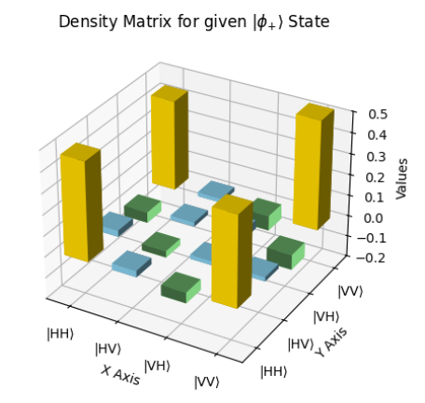The density matrix plot for the ∣ϕ+⟩ state demonstrates the signature of maximal entanglement. The diagonal elements, showing equal probabilities of 0.5 for the ∣HH⟩|HH⟩ and ∣VV⟩|VV⟩ states, reflect the equal weighting of these components in the superposition. The significant off-diagonal elements (coherence terms) with values of 0.5 indicate strong quantum correlations between the ∣HH⟩∣HH⟩ and ∣VV⟩∣VV⟩ states, confirming the presence of entanglement. The structure of the density matrix, with both diagonal and off-diagonal terms, confirms that the state is not separable and represents a pure, maximally entangled Bell state.

Figure 06: Density Matrix for $ϕ_{+}$ Bell State

Similarly for the Separable State the density matrix was obtained as follows,

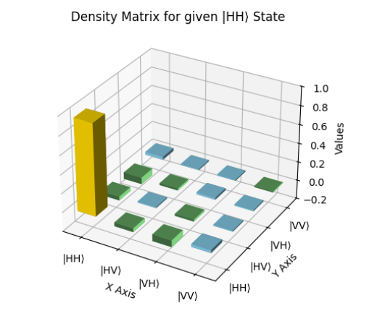The density matrix plot for the ∣HH⟩∣HH⟩ state illustrates a pure, separable quantum state with no entanglement. The single nonzero diagonal element at ∣HH⟩∣HH⟩ with a value of 1 indicates that the system is entirely in the ∣HH⟩∣HH⟩ state, while all other diagonal elements, corresponding to other states, are zero. The absence of off-diagonal elements confirms there is no coherence or quantum correlation between different states, highlighting that this is not a superposition or entangled state.

*[Note: In Both the Plots the Green Coloured Bars are representing the negative values and are going below the axis plane but not rising above.]*

Figure 07: Density Matrix for ∣HH⟩ State

The Concurrence values were calculated for both the cases and it was found to be as follows,

* Concurrence for Entangled State: 0.544
* Concurrence for Separable State: 0

If a state is separable, it can be written as a tensor product of individual pure states, and there is no quantum entanglement between the subsystems. Thus, for separable states, the concurrence is 0, indicating no entanglement. Whereas for the entangled state we obtained.

When the test for the if the measured density matrix fulfils the criteria of a physical matrix was done.

The following criteria were taken into account,

* Unit Trace of Density Matrix
* Hermitian Test
* Positive Semi Definiteness Test
* Purity Test.

For the entangled state the test results are as follows,

|  |  |
| --- | --- |
| Unit Trace | Passed |
| Hermitian Test | Passed |
| Positive Semi Definiteness Test | Failed |
| Purity Test | Mixed State. (0.88) |

The Eigen Values were obtained for Positive Semi Definiteness test, [-0.038939, 0.03355518, 0.07039601, 0.93498781]. As we have one negative eigenvalue it shows the failure of the Positive Semi Definiteness Test.

The trace of the squared matrix is 0.88 < 1. For a pure state this value needs to be equal to 1. Hence the Entangled state here is not a pure state.

For the Product State the test results are as follows,

|  |  |
| --- | --- |
| Unit Trace | Passed |
| Hermitian Test | Passed |
| Positive Semi Definiteness Test | Failed |
| Purity Test | Pure State. (0.96 $≈$ 1) |

The Eigen Values which were obtained for the Positive Semi Definiteness test, [-0.02752493 0.00519673 0.03483025 0.97749794]. As we have one negative eigenvalue it shows the failure of the Positive Semi Definiteness Test.

About the Purity test for the product state, theoretical we are supposed to be getting 1 itself but due to experimental imperfections or due to noise presence experimentally we obtained the trace of squared matrix as 0.96 which is very close to 1. Hence, we can consider this to be a pure state.

Overall, since both Entanglement State and Separable State fail the positive semi definiteness test, we can say that both states don’t fulfil the criteria for physical matrix. To correct this, we can use Maximum Likelihood Estimation (MLE) to ensure that density matrix selected is the “most-likely” matrix which is physically possible. A density matrix that violates this may be due to experimental uncertainties or statistical fluctuations of the coincidence counts

*Why are 16 coincidence measurements required for two-qubit tomography? How many measurements are necessary for single qubit tomography and which measurements?*

For **two-qubit tomography**, you need 16 coincidence measurements because each qubit has 4 possible states (|H⟩, |V⟩, |+⟩, |-⟩) when measured in different bases (like computational or diagonal). To fully reconstruct the state of two qubits, you need to measure all combinations of these bases, which results in 4×4=16 independent measurements. For a single qubit 4 measurements are sufficient. The general case of 𝑛 qubits $4^{n}$ measurements.

For the given density matrix,

$$\hat{ρ} = \left[\begin{matrix}0⋅25 & 0 & 0 & 0.33 \\ 0 & 0.18 & 0.1 & 0 \\ 0 & 1 & 0.12 & 0 \\ 0.17 & -0.1 & 0 & 0.4\end{matrix}\right]$$

The following plot was obtained and its purity and concurrence were found to be as follows,

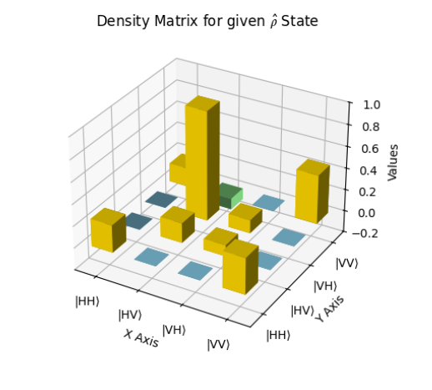

Figure 08: Density Matrix for given state

* Purity: 0.62 < 1. Hence it is a Mixed State.
* Concurrence: 0.04125. You can say some level of entanglement is seen.

From the above points we can say the quantum state is mixed state but exhibits entanglement.

## Conclusions

The experiment successfully demonstrated the principles of quantum entanglement through various measurements and analyses. By generating entangled photon pairs using spontaneous parametric down-conversion (SPDC) in a setup with crossed BBO crystals, we achieved maximally entangled Bell states, as evidenced by the violation of the CHSH inequality. The measured S-parameter exceeded the classical limit of 2, reaching a value of 2.591, confirming quantum non-locality and the entangled nature of the photon pairs. Quantum state tomography was utilized to reconstruct the density matrices for both entangled and separable states, revealing distinct characteristics. The density matrix for the entangled state displayed strong quantum correlations with significant off-diagonal elements, while the separable state showed only diagonal elements, confirming the absence of entanglement. Despite some experimental imperfections, such as deviations in the positive semi-definiteness test and slight discrepancies in visibility, the results align closely with theoretical predictions, validating the experimental setup and methods.

This experiment has been instrumental in deepening our understanding of the unique properties of quantum systems, particularly the phenomenon of entanglement and its departure from classical local realism. We learned how to implement and analyse the CHSH inequality, perform quantum state tomography, and interpret density matrices for characterizing quantum states. Additionally, the practical challenges encountered, such as experimental noise and imperfections, highlighted the importance of precision in quantum measurements and the role of techniques like Maximum Likelihood Estimation for ensuring accurate results. Overall, this experiment has provided valuable insights into the fascinating realm of quantum mechanics and strengthened my skills in experimental design and data analysis in this field.

*References*

[1] D. F. V. James, P. G. Kwiat, W. J. Munro and A. G. White, "Measurement of qubits," Physical Review A, vol. 64, no. 5, pp. 052312-1 - 052312-15, 2001.

[2] Arjun Kudinoor , Aswath Suryanarayanan, “Violating the CHSH Inequality Using Entangled Photons”, Columbia University, 29/10/2022

[3] QuTools. qued: Entanglement demonstrator

[4] Quantum Laboratory Lab Manual for Quantum Entanglement (Abbe Centre of Photonics)

*Appendix*